Assignment 03

**Host Discovery**

**CS4061**

**Ethical Hacking Concepts and Practices**

**Submitted by:** Ayesha Sajid

**Roll number:** 20I-0862

**Date:** 17/03/2024

Contents

Introduction 3

Host Discovery Techniques 3

1. ARP Ping Scan: 3

2. ICMP Ping Scan 4

ICMP Echo Ping 4

ICMP Echo Ping Sweep 4

ICMP Timestamp Ping 5

ICP Address Mask Ping 6

Port Scan 7

4. TCP Ping Scan 8

TCP SYN Scan 8

TCP Ack Scan 9

TCP Null Scan 11

TCP XMAS Scan 11

TCP FIN Scan 12

5. IP Protocol Ping Scan 13

ICMP , TCP , UDP : 13

References: 14

# Introduction

In this assignment, we're diving into practical ethical hacking skills by exploring network scanning techniques. Using tools like Nmap and Hping. The goal is to perform tasks like ARP and ICMP Ping Scans, UDP and TCP Ping Scans, and more. The practice involves using Parrot or Kali OS for the attacker machine and trying different victim machines like Windows, Linux, or servers. The focus is on learning ethical hacking concepts while being mindful of responsible use. we've used tools like Nmap and scapy to explore a network by checking which devices are connected and what services they're running.

# Host Discovery Techniques

Following host discovery techniques must be incorporated through your developed tool:

# ARP Ping Scan:

**Command:**

“sudo nmap -PR target ip”

ARP Ping Scan that's utilized to discover active hosts within a local network segment by resolving their IP addresses to physical MAC addresses using the Address Resolution Protocol (ARP). The ARP Ping Scan is used to discover hosts on a local network. In this case, the scan targeted the IP address 192.168.10.1.The host responded quickly to the ARP ping, indicating that it is online.

**Output:**

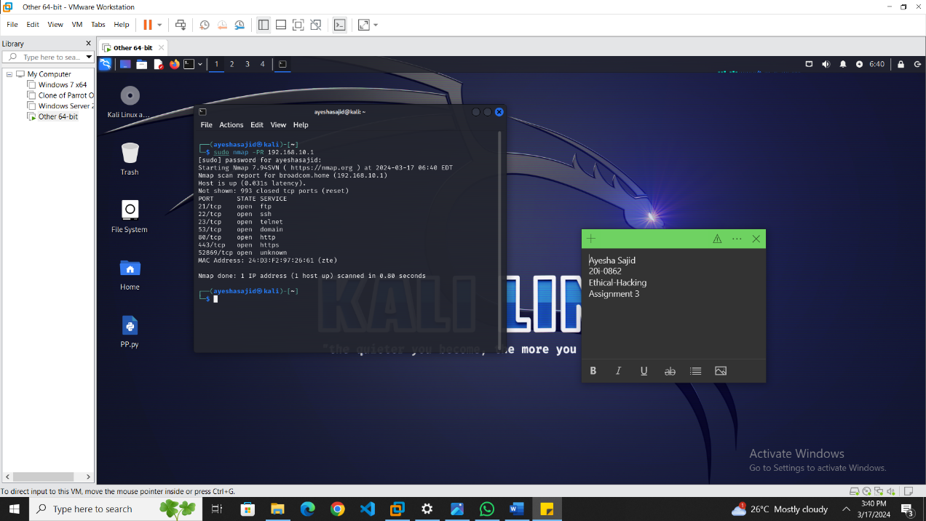

# ICMP Ping Scan

### ICMP Echo Ping

**Command:**

“sudo nmap -sn target ip”

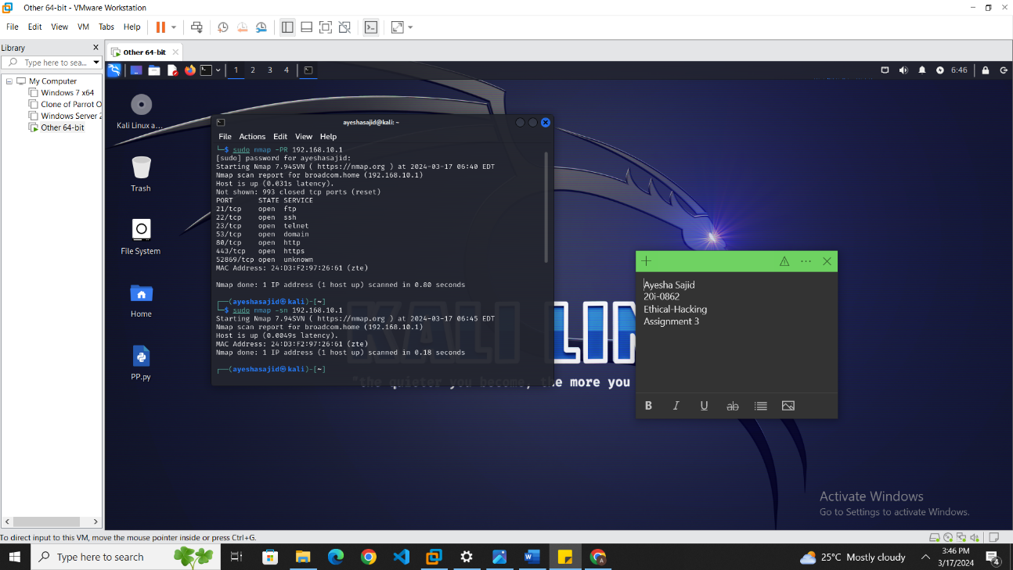

Determines which IP addresses are active by sending an ICMP echo request. It is one of the most common methods for quickly checking if hosts on a network are responsive.

### ICMP Echo Ping Sweep

**Command:**

“sudo nmap -sn -PE target ip”

Similar to the ICMP Ping Scan, but typically refers to scanning a broad range of IP addresses. It shows which hosts are live on the network by awaiting echo replies.

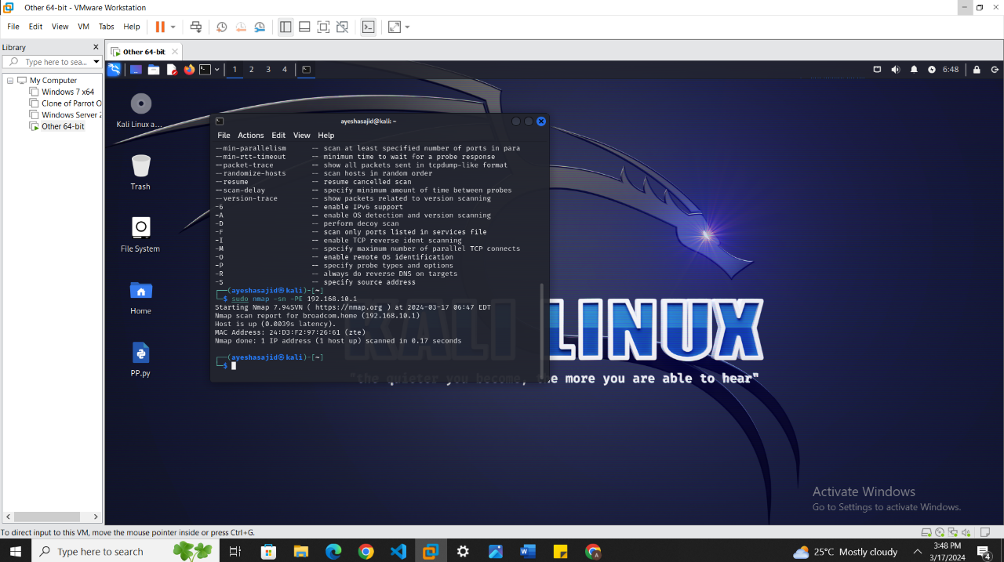

### ICMP Timestamp Ping

**Command:**

“sudo nmap -PP target ip”

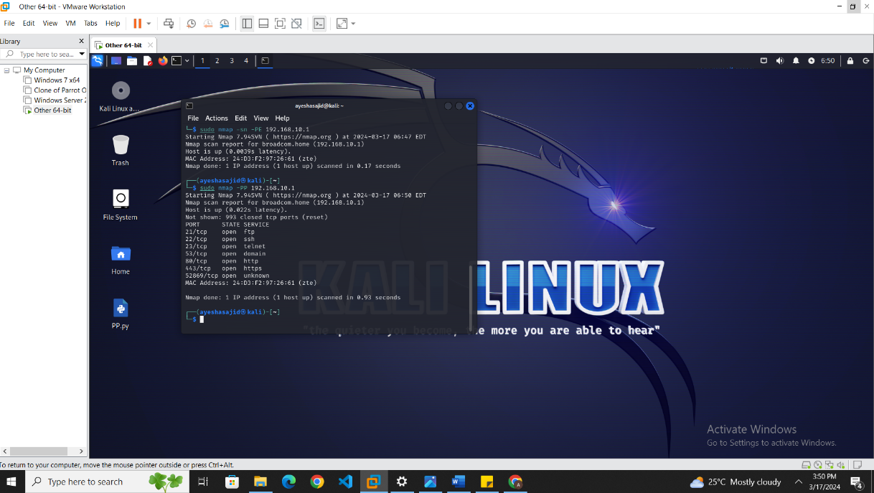

This command will send ICMP Timestamp Request packets to the target IP address to gather information about the time on the target system.

### ICP Address Mask Ping

**Command:**

“sudo nmap -PM target ip”

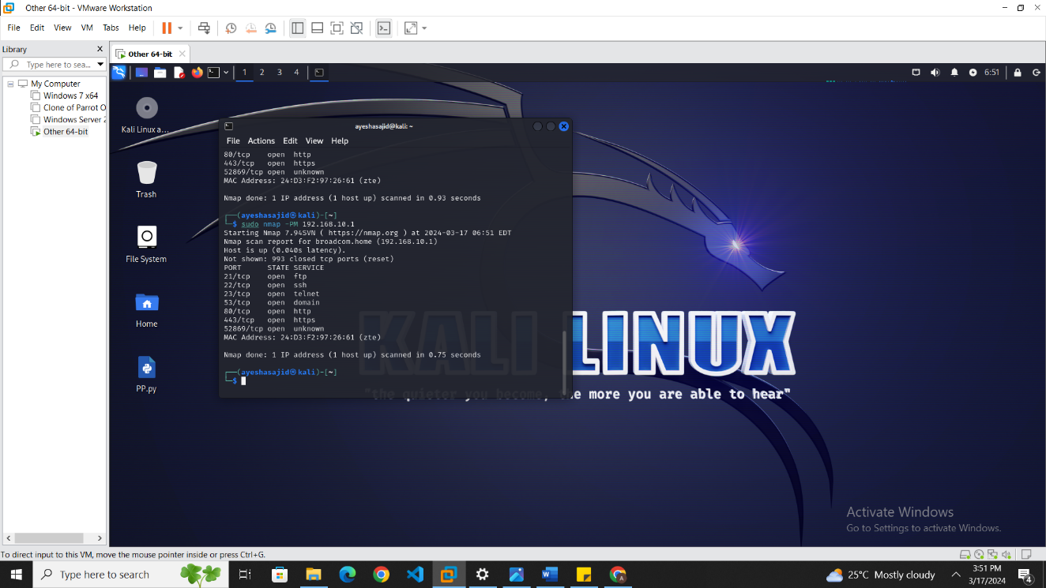

This command will send ICMP Address Mask Request packets to the target IP address to gather information about the subnet mask used by the target system.

3. UDP Ping Scan

### Port Scan

**Command:**

“sudo nmap -PU target ip”

This command will initiate a UDP Ping scan against the specified target IP address. In a UDP Ping scan, Nmap sends UDP packets to common UDP ports on the target and determines whether the ports are open, closed, or filtered based on the response behavior. However, please note that the **-PU** option does not directly include port scanning; it only performs host discovery using UDP probes.

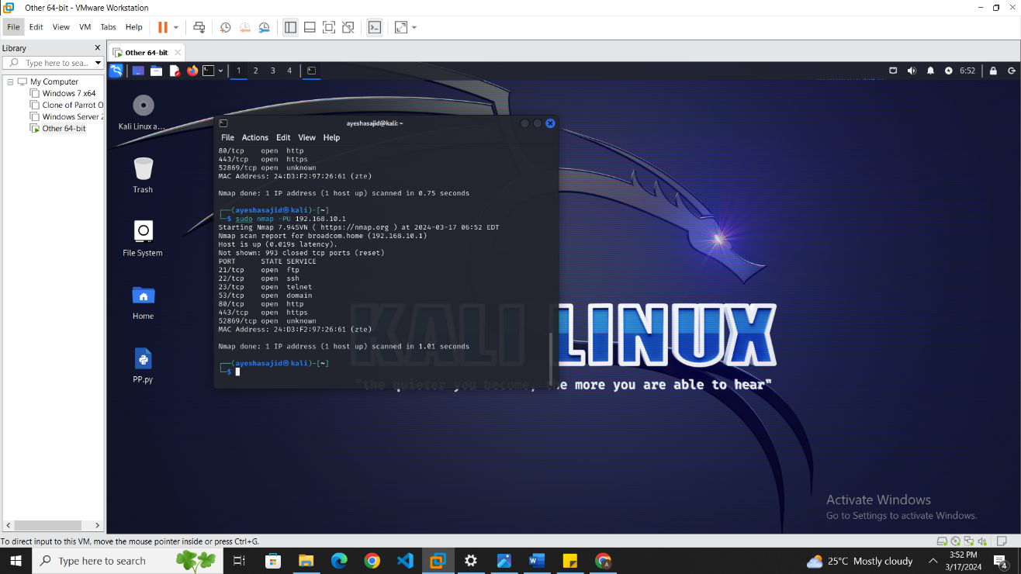

# 4. TCP Ping Scan

### TCP SYN Scan

**Command:**

“sudo nmap -sS target ip”

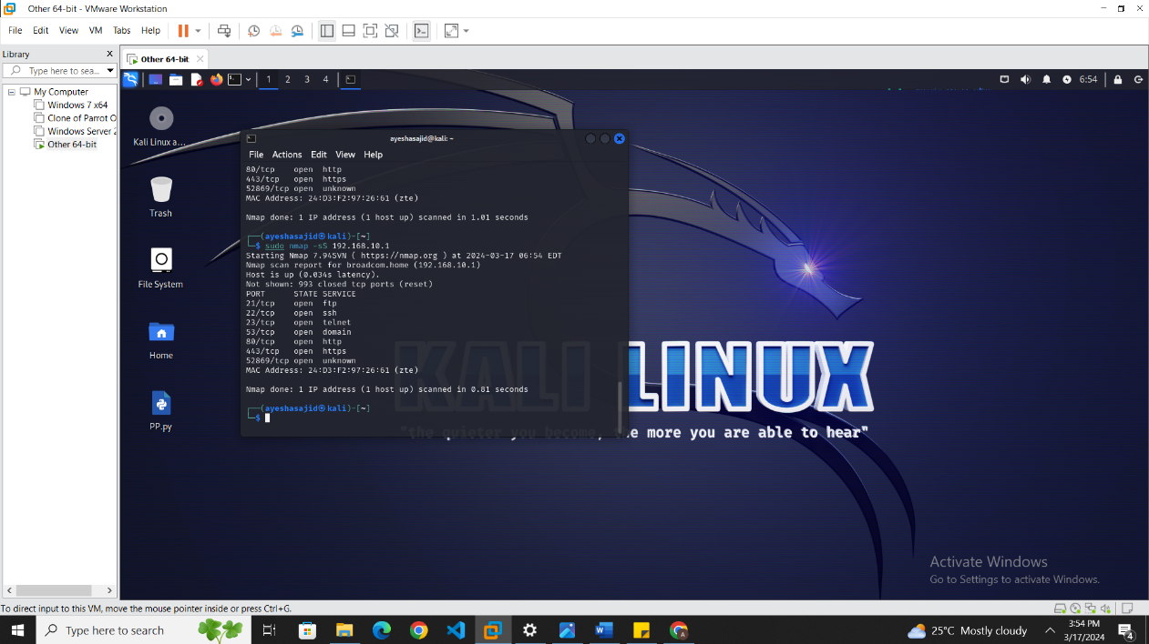

This command will initiate a TCP SYN scan against the specified target IP address. In a TCP SYN scan, Nmap sends SYN (synchronize) packets to the target's ports, and based on the response behavior, it determines whether the ports are open, closed, or filtered.

### TCP Ack Scan

**Command:**

“sudo nmap -sA target ip”

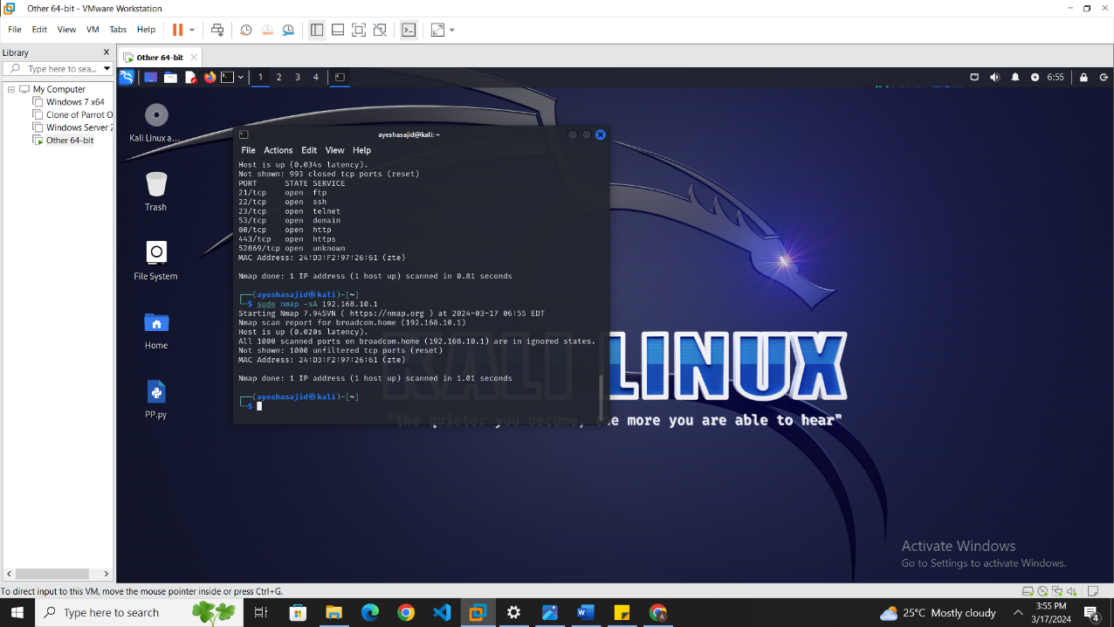

This command will initiate a TCP Ack scan against the specified target IP address. In a TCP Ack scan, Nmap sends TCP packets with the ACK (acknowledgment) flag set, aiming to determine the state of ports based on the response behavior.

### TCP Null Scan

**Command:**

“sudo nmap -sN target ip”

A Null scan turns off all flags, creating a theoretically empty TCP packet. In response, closed ports are expected to reply with a RST packet, while open or filtered ports will not respond at all.

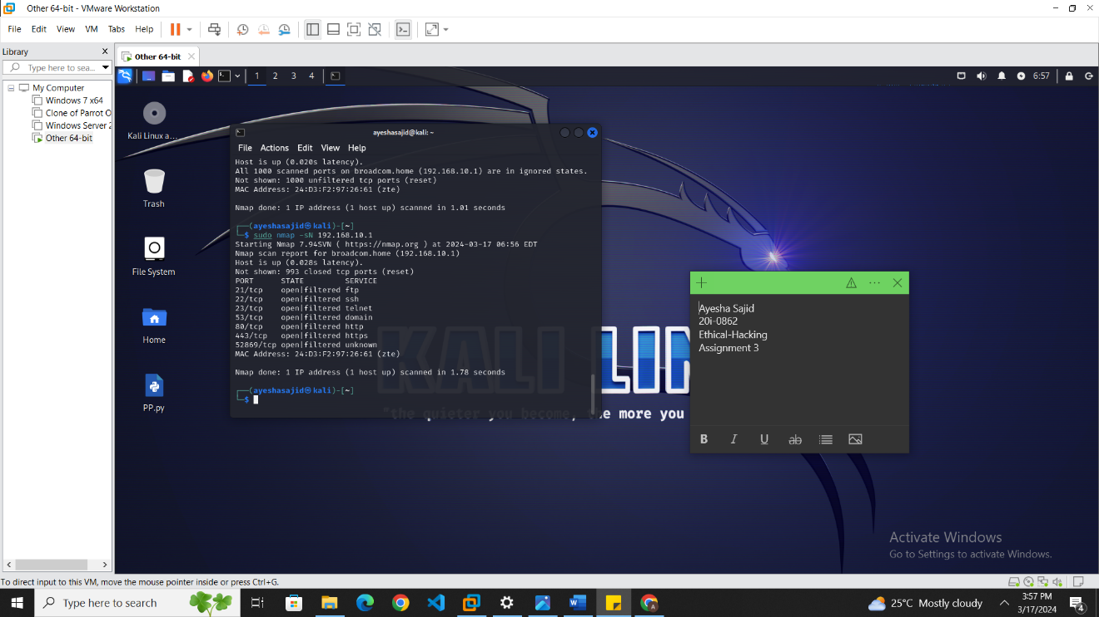

### TCP XMAS Scan

**Command:**

“sudo nmap -sX target ip”

The Xmas scan sends packets with the FIN, PSH, and URG flags lit up, similar to a Christmas tree. Open ports won't respond, but closed ports should reply with a RST, in theory. However, the actual response can vary based on the network stack of the operating system.

**Output:**

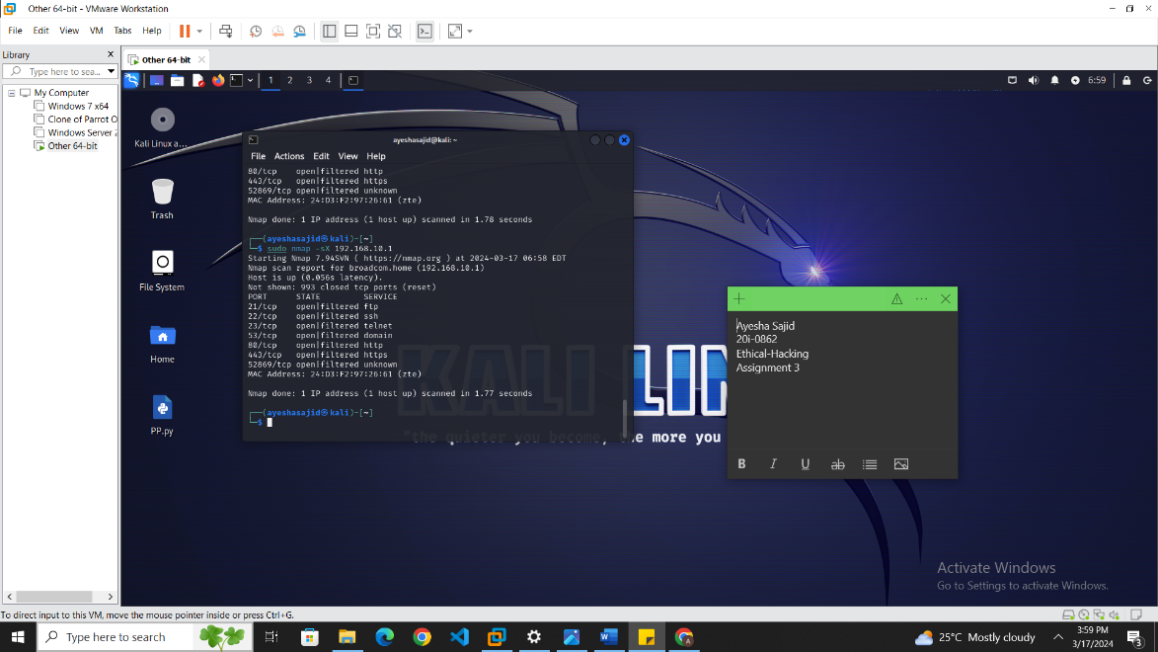

This command will initiate a TCP XMAS scan against the specified target IP address. In a TCP XMAS scan, Nmap sends TCP packets with the URG (urgent), PSH (push), and FIN (finish) flags set, aiming to determine the state of ports based on the response behavior.

### TCP FIN Scan

**Command:** “sudo nmap -sF target ip”

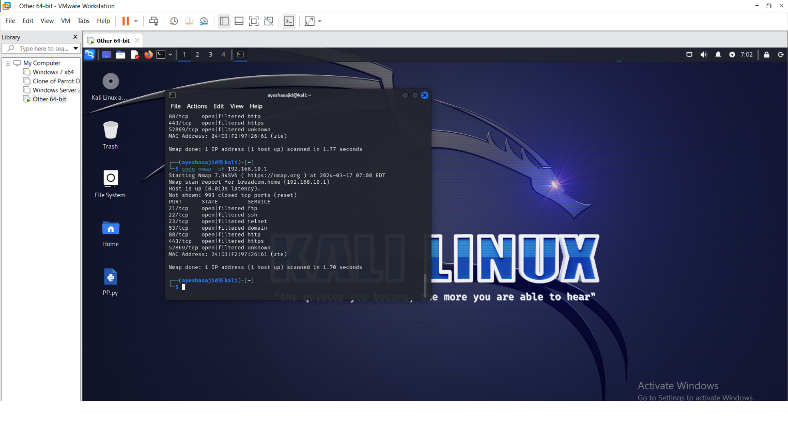

This command will initiate a TCP FIN scan against the specified target IP address. In a TCP FIN scan, Nmap sends TCP packets with the FIN (finish) flag set, aiming to determine the state of ports based on the response behavior.

# 5. IP Protocol Ping Scan

### ICMP , TCP , UDP :

**Command:**

“sudo nmap -PO -PS -PU target ip”

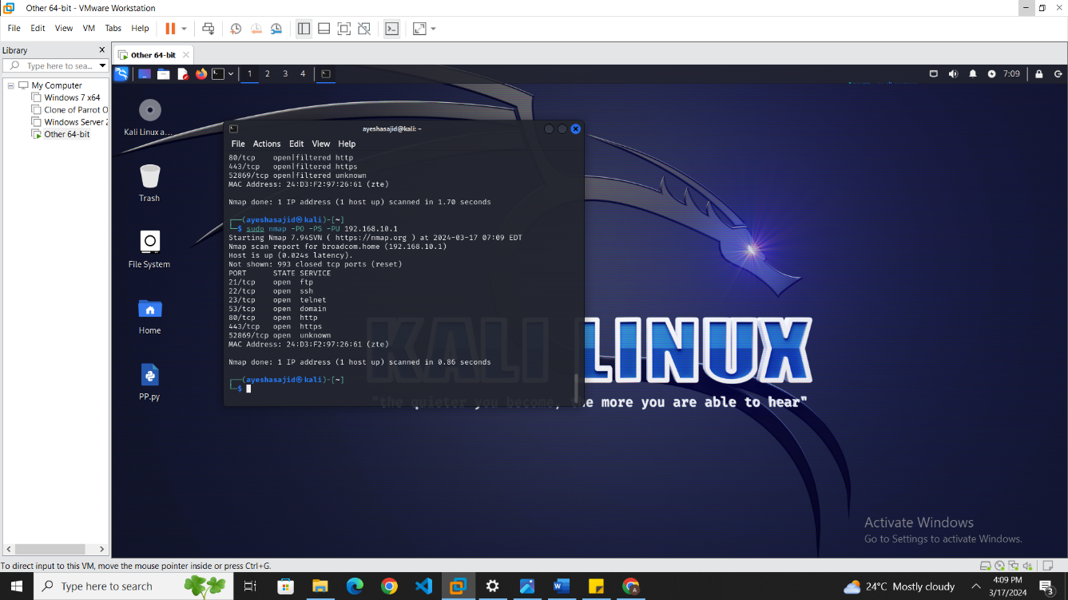

# References:

[Gpt](https://chat.openai.com/c/e5fcf40a-4303-44dd-a836-8e7616e96df6)

**https://chat.openai.com/share/44a64ddb-eb1e-4f3c-b4c7-98215eb822f1**